Project 3B – Problem and Description

For this portion of the project it was asked to input a string of postfix expression (1), and then evaluate the postfix expression and print the result (2).

1. The first task was to receive the input from the user for the expression to be evaluated:

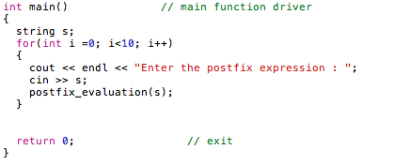

1. The second task was to convert the expression given into the actual result. This was accomplished through pushing the values solving for the variable that were on the stack. During the process there was handling for the operator signs in order to return the right result:

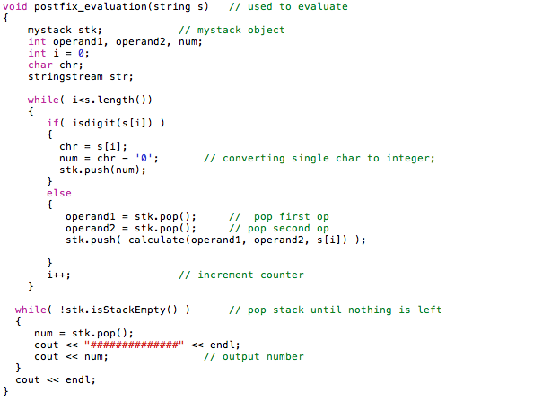

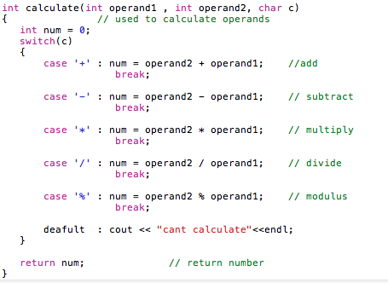

**Test Input and Output**

Enter the postfix expression : 88+

##############

16

Enter the postfix expression : 97-9+

##############

11

Enter the postfix expression : 65+45-

##############

-1##############

11

Enter the postfix expression : 60+

##############

6

Enter the postfix expression : 49+89--

##############

14

**Postfixevaluate.cpp**

